Artificial Intelligence for Quality Assurance and Troubleshooting in Industry

Rudolf Hoffmann1, Slimane Arbaoui2, Léa Charbonnier3, Amel Hidouri2, Ali Ayadi2, Franco Giustozzi2, Thomas Heitz4, Julien Saunier3, Frédéric Pelascini4, Christoph Reich1, Ahmed Samet2, Cecilia Zanni-Merk3

1 Institute for Data Science, Cloud Computing and IT Security; Furtwangen University; 78120 Furtwangen im Schwarzwald Germany

[rudolf.hoffmann@hs-furtwangen.de,](mailto:rudolf.hoffmann@hs-furtwangen.de,) christoph.reich@hs-furtwangen.de

2 ICube, CNRS (UMR 7357) INSA Strasbourg, University of Strasbourg, 67000 Strasbourg, France

3 INSA Rouen Normandie, Normandie Univ, LITIS UR 4108, F-76000 Rouen, France

4 Cetim, 67400, Illkirch-Graffenstaden

**Abstract.**

This paper explores the application of Artificial Intelligence (AI) to contribute to the improvement of quality assurance and troubleshooting in manufacturing. The goal is to identify and resolve quality issues effectively using AI techniques, applying Explainable AI (XAI) to ensure transparency and comprehensibility. We propose three approaches to tackle these industry challenges: semantic reasoning, Long Short-Term Memory (LSTM) networks for time series quality prediction, and a combined Machine Learning (ML) and Fault Tree Analysis (FTA) method for comprehensive fault detection and analysis.

**Keywords:** AI; XAI; Time Series; Fault Tree Analysis; Quality Assurance;

1. Introduction

In the present globalized economic era, industry competition demands continuous quality and reliability. Monitoring manufacturing processes is essential to prevent failures and maintain product quality. Artificial Intelligence (AI) enhances quality control and fault detection by automating tasks traditionally handled by humans, using Machine Learning (ML) and Deep Learning (DL) to improve accuracy and consistency in defect detection [1]. Traditional troubleshooting methods like Root Cause Analysis (RCA) are extended by AI techniques to analyze vast amounts of data from multiple sources, improving fault detection and prediction [2]. For the stable deployment of AI-based systems and their acceptance by experts and regulators, it is crucial that the decisions and results produced by these systems are comprehensible, interpretable, and transparent; in other words, “Explainable” [3].

Our work aims to leverage AI techniques to enhance quality assurance and troubleshooting processes in various industries by developing methods for precise defect detection, predictive maintenance, and effective RCA.

1. Approaches

Figure 1 shows the X-Quality framework. Data is collected from each machine and AI/XAI methods provide the prediction and explanation for the operators. In parallel, expert knowledge is capitalized as an ontology (a formal model that allows reasoning). The whole will provide integrated explanations to help the foreman identify and understand the origins of quality issues.

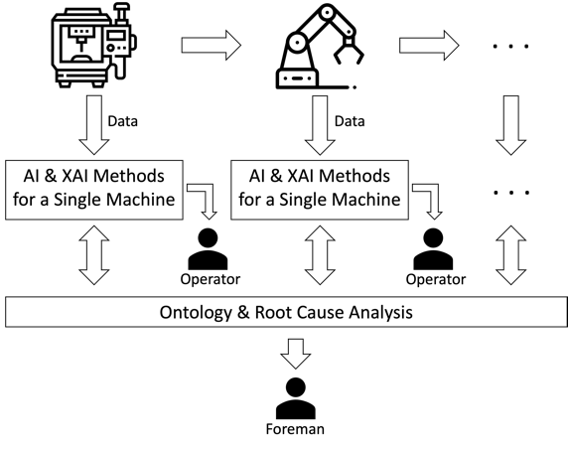 Time series anomaly detection is crucial for Industry 4.0, ensuring predictive maintenance and quality control by spotting rare deviations from normal behavior. This work merges advanced data mining methods with XAI techniques to identify anomalies. Utilizing the matrix profile combined with SHAP (SHapley Additive exPlanations) enhances anomaly detection and makes decision-making transparent. Our model addresses the challenge of anomaly detection, enabling early failure detection and supporting proactive maintenance. This demonstrates the method's effectiveness in improving operational efficiency and quality control.

Figure 1: X-Quality Framework

Building upon this, the second approach combines AI and FTA to further enhance the predictive and explanatory power of our system. AI is used to predict Basic Events (BEs) within Fault Trees (FTs), converting these predictions into probabilities to determine the likelihood of the Top Event (TE). This enhances transparency and understanding of system failures. In our experiment we first classified the TE directly. Next, we classified the underlying BEs and used them to determine the TE. This approach outperformed the approach mentioned before. It improves the prediction accuracy, identifies the root causes and provides interpretability.

The insights gained from these AI/XAI methods are then used to exploit a domain ontology, built from expert knowledge. Stream Reasoning plays a key role here by enabling the continuous querying of heterogeneous data streams coming from different sources in real time and incorporating logical reasoning over the data. In anomaly detection, this approach enables to detect quality issues coming from the streams and to enrich the ontology. Reasoning over the ontology allows to explain the origin of the detected quality issue. A first illustrative case study about quality assurance succeeded in detecting anomalies and proposing an explanation.

1. Conclusion

In conclusion, the X-Quality framework combines machine data with AI/XAI methods to provide predictions of future quality issues and explanations with the possible failures that are producing the quality issue upstream in the production line. This approach will allow the reductions of costs and the improvement of the operational efficiency and maintenance through transparent, data-driven decision-making.

References

1. Yang, H. and Kim, Y. (2022). Design and implementation of machine learning-based fault prediction system in cloud infrastructure. Electronics, 11(22).
2. Ahmed, I.; Jeon, G.; Piccialli, F. From Artificial Intelligence to Explainable Artificial Intelligence in Industry 4.0: A Survey on What, How, and Where. IEEE Trans. Ind. Inform. 2022, 18, 5031–5042.